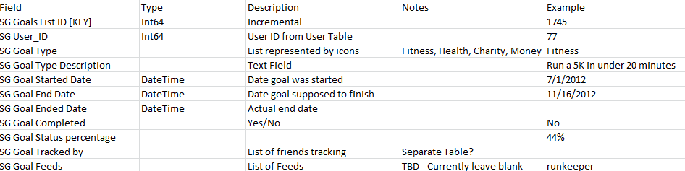
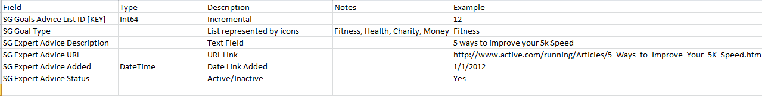
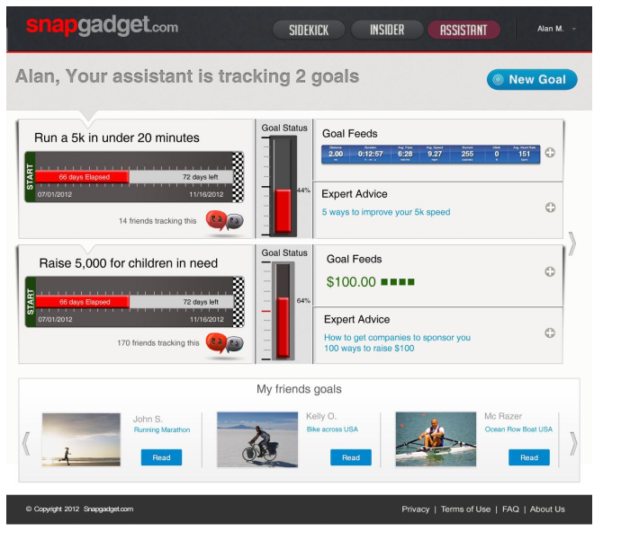
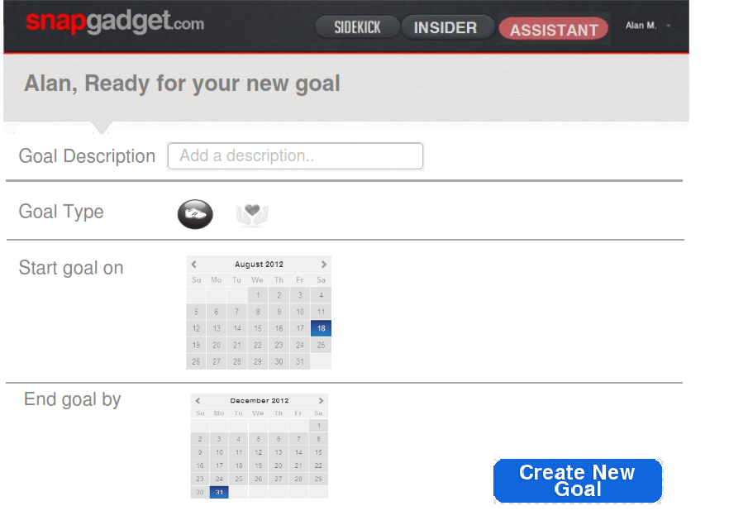
Assistant Specifications (V1.0)

Goals Table

Goals advice Table

Assistant Main Page

Screen Logic
- User will click on Assistant menu option
- Code will read the Goals Table by reading all goals where goals.SG_user_id = %userId and SG Goal completed = ‘No’ (or 0 if using Boolean for field) order by desc goal started date (so newest goal first)
- For each goal found (add scroll buttons if required)
  - Display SG Goal Type Description, SG Goal Started Date, SG Goal End Date, SG Goal Status percentage
  - Display count of SG Goal Tracked by (may have to look through another table?)
  - Using current date - Calculate the days since goal start, and days left
    - Display on start finish grid (as in screenshot above)
  - Display SG Goal Status percentage (Currently this field is in the table, but is not being updated)
  - Display share button to allow goal to be shared with friends
  - Clicking on this launches share button
  - Loop through all Goal feeds and display data
    - TBD – currently this would be blank
  - Determine expert advice to display
    - Select latest 5 goal advice records from the goal advice table where goalsadvicetable.goaltype = goalstable.goaltype and goalsadvicetable.expertadvicestatus = active order by desc expert.advice.added (so match the goal type for the record against the table, selecting only active ones, and then order then by latest created first getting the five ‘top’ records’. There may be less than 5)
    - Display sg expert advice description and hyperlink it to sg expert advice url
      - If user clicks link it should go to popup window passing url
- Once all goals are displayed, loop through the Friends table getting friends IDS
  - For each ID found, read the goals table using friends ID and if the SG Goald tracked by field contains the %userid (logged on user) then display
    - Friend name, goal type description, goal type icon
  - Add Scroll buttons if required

Assistant New Goal

Screen Logic
- User will click on new goal
- New page will launch and user will be prompted for
  - Goal description, goal type (icon, clickable to select), Start goal, End Goal
- If user selects create new goal (may need cancel button?) then write a record to the goals table
  - SG Goals List ID [KEY] - read count table, increment by 1, then use this as key for new record
  - SG User_ID = %userId
  - SG Goal Type = (from screen input converting picture to type ie fitness
  - SG Goal Type description = from screen input
  - SG Started Date = from screen input
  - SG End Date = from screen input
  - SG Goal Ended Date = null
  - SG Goal Completed = ‘No’ (or ‘0’)
  - SG Goal Status percentage = 0
  - SG Goal Tracked by = ‘null’
  - SG Goal Feeds = null
- On completion of write, then go back to main assistant page, this goal should now be displayed

